1. [20 points] Which of the following statements about the autonomic nervous system is the most correct? Re-write the choices that, as written now, are wrong so that they will be correct once you change them.
   1. Sympathetic preganglionic nerves are longer than parasympathetic preganglionic nerves.
   2. ACh is the preganglionic neurotransmitter for the sympathetic and for the parasympathetic branches of the autonomic nervous system.
   3. Parasympathetic postganglionic neurons arise from the paravertebral ganglia.
   4. The parasympathetic postganglionic neurotransmitter is epinephrine.
   5. Sympathetic preganglionic nerves are longer than parasympathetic preganglionic nerves.

Sympathetic preganglionic nerves are shorter than parasympathetic preganglionic nerves.

* 1. ACh is the preganglionic neurotransmitter for the sympathetic and for the parasympathetic branches of the autonomic nervous system.

Correct

* 1. Parasympathetic postganglionic neurons arise from the paravertebral ganglia.

Sympathetic postganglionic neurons arise from the paravertebral ganglia.

* 1. The parasympathetic postganglionic neurotransmitter is epinephrine.

The sympathetic postganglionic neurotransmitter is epinephrine

1. [20 points] Heart rate varies with respiration, being higher during inspiration than expiration. Describe/discuss/explain the mechanism(s) involved.

During inspiration, there is an increase of the thoracic cavity, stretch receptors in the lung are stimulated which triggers a decrease in the vagal drive, which increases the heart rate. At the same time, during inspiration, the chest cavity expands. Since this is a closed space, the volume of gas (V) increasing, the intrathoracic pressure (P) decreases (from the gas law P V = (n R T) = constant since the Temperature (T) did not change, nor did the number of moles (n) of gas present). As a result of a decrease of the intrathoracic pressure there is an increase venous return to the right side of the heart. The consequent stretch of the right atrium triggers the Bainbridge reflex which increases the heart rate (by decreasing the drive to the cardiac vagal center).

After the time delay required for the increased venous return to reach the left side of the heart, left ventricle output increases and raises arterial blood pressure. This rise in arterial blood pressure initiates the baroreceptor reflex which increases the drive to the cardiac vagal center decreasing the heart rate during expiration.

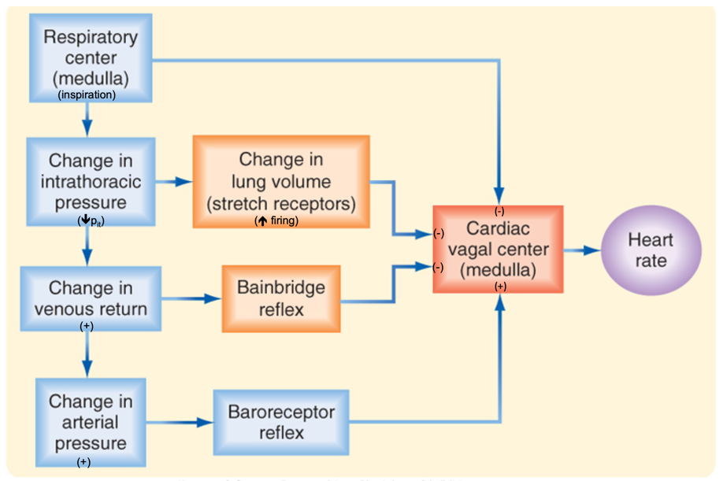

**Fig. 1**: Respiratory sinus arrhythmia (Module 9, video 3, slide 8)

1. [20 points] In video 3 of this Module there was a brief mention of atrial stretch receptors, but no details were provided. So – describe/explain the several physiological consequences of stimulating (stretching) the atrial stretch receptors and briefly discuss whether (or not) the physiological consequences are consistent with the original stimulus.

Atrial stretch receptors are low pressure receptor found in the walls of the atria. They are also called volume receptors. These receptors respond to changes in the wall tension, which is proportional to the filling state of the low-pressure side of circulation. Thus, low pressure baroreceptors are involved with the regulation of blood volume. The blood volume determines the mean pressure throughout the system, in particular in the venous side where most of the blood is held. Increased blood volume results in increased venous return to the heart, this results in an increase in the pressure of the right atrium. When these receptors are stretched, they signal the medullary control centers to decrease parasympathetic tone via the vagus nerve to the heart, leading to increased heart rate . Sympathetic activity of the sinus node is also increase. These changes in sympathetic activity heart rate. Stimulation of the atrial receptors increases also urine volume, serving to lower blood pressure.

The original stimulus is an increase of venous return, as venous return increases, pressure in the superior and inferior vena cavae increases which results in an increase of pressure of the right atrium which stimulates the atrial stretch receptors (see above).

Increasing the heart rate, serves to decrease the pressure in the superior and inferior vena cavae by drawing more blood out of the atrium. This results in a decrease in atrial pressure, which serves to bring in more blood from the vena cavae, resulting in a decrease in the venous pressure of the great veins. This continues until right atrial blood pressure returns to normal levels, upon which the heart rate decreases to its original level (source: Wikipedia).